[1]

Ph.D. Supervisory Meeting – Briefing Notes

(30th April 215)

Andy Wicks  
For : Prof. Liz Bacon, Prof. Lachlan MacKinnon, Dr. Cos Ierotheou

*Abstract*—The work presented here is NOT a paper, but merely in the format of one. The document covers two areas; the progress on the reference manager program and joining the dots between the thinking on the role and use of the axiomata. This technique could explain how the opposing views of education might be bought under one umbrella to shelter them from the constant rain of the latest “good” idea. The briefing notes end with a short discussion on how the theory could be tested.

*Index Terms*—Referencing software, ARM (Academic Research Manager), recap of ideas so far, explanation of current thinking

# INTRODUCTION

I

T seemed like a nice idea to format this briefing document as if it were a submission for an academic journal. At least this way I can demonstrate that writing is not a problem. As you can tell, this is the IEEE template. Is there one for BCS?

The progress of both the Academic Research Manager program, ARM and the theory derived from the literature are discussed below.

From the literature, it seems there are two competing views of education; the utilitarian view which sees education as a means to employment and the idealistic view which tries to optimise education for the individual. The utilitarian view relies on a set of syllabi to decide on content, whilst the material covered by idealistic view is student-driven.

# ARM (Academic Reference Manager)

The last meeting with Lachlan in January it was agreed that it would be useful for me to take “time out” to organise the citations. However, the start of the marking season and the death of my father-in-law meant that there was little in the way of chunks of time to be used to work on my PhD. I have therefore not completed nearly as much of the program, ARM (Academic Research Manager), as I would have liked. The program is coming on and has a little functionality, but it still needs a lot of work before it will do what I need. Currently, its major capabilities are being able to:-

* organise the literature by assigning the references to a tree structure.
* view an abstract when rolling over the reference which makes finding things easier.
* create outlines of papers and attaching references to them.
* export the references to a Bibtex file so that they can be incorporated easily into a Word document.

Much of this is quite clunky, though and the program needs a lot of work before it becomes really useful.

# The Utilitarian View of education

The diagram below represents the traditional view of education. This was developed in the 19th century by those who believed education was a social good that should lead to employment   
  
  
  
  
  
  
  
  
  
  
  
  
  
  
  
  
  
  
  
  
  
  
  
  
  
  
  
  
  
  
  
  
  
  
(Gillard 2011). These new types of schools considered the 3Rs to be essential and that any other learning would be based on the technique of rote learning. “Teacher knows best” is the model for the educational system still used in primary and secondary education (and to some extent in tertiary).

This view puts teachers and learners together and expects their interaction to produce learning. The amount of overlap is assumed to be related to the quality of the teacher and learner.

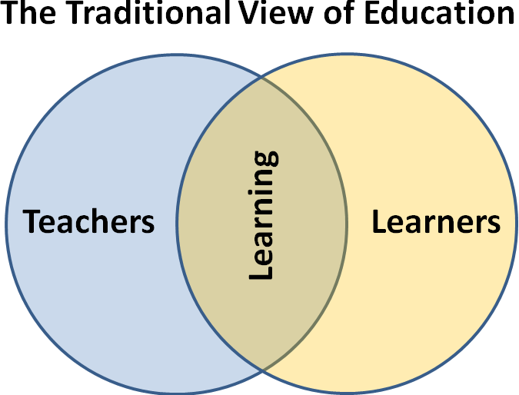

The major discussions in this view are over how the area of learning can be maximised. Should we be assessing for learning styles and, if so, which   
  
  
  
  
  
  
  
  
  
  
  
  
  
  
  
  
  
  
  
  
  
  
  
  
  
  
  
  
  
  
  
  
  
  
  
(Fleming 1995)? How should the syllabus be managed   
  
  
  
  
  
  
  
  
  
  
  
  
  
  
  
  
  
  
  
  
  
  
  
  
  
  
  
  
  
  
  
  
  
  
  
  
  
  
  
  
  
(Vygotsky 1978)? Which learning strategies work   
  
  
  
  
  
  
  
  
  
  
  
  
  
  
  
  
  
  
  
  
  
  
  
  
  
  
  
  
  
  
  
  
  
  
  
  
  
(Kolb & Fry 1974)?, etc. See a more exhaustive list [here](http://lordwicks.co.uk/phd-TopicPlan.php).

# The Idealistic View of Education

This has a longer lineage than our current model. The Socratic School   
  
  
  
  
  
  
  
  
  
  
  
  
  
  
  
  
  
  
  
  
  
  
  
  
  
  
  
  
  
  
  
  
  
  
  
  
  
  
  
(Overholser 1993) used question and answer to allow the scholar to explore ideas and find logical, consistent answers to problems. The work of Comenius   
  
  
  
  
  
  
  
  
  
  
  
  
  
  
  
  
  
  
  
  
  
  
  
  
  
  
  
  
  
  
  
  
  
  
  
(Comenius 1986) and Rousseau   
  
  
  
  
  
  
  
  
  
  
  
  
  
  
  
  
  
  
  
  
  
  
  
  
  
  
  
  
  
  
  
  
  
  
  
  
  
  
(Rousseau & Bloom 1979) in the 17th and 18th centuries was also of this genre. However, the real impetus for this view came during the 1960s with the publications by John Holt and others who argued that the current system was failing a lot of good students who were “afraid, bored, and confused”   
  
  
  
  
  
  
  
  
  
  
  
  
  
  
  
  
  
  
  
  
  
  
  
  
  
  
  
  
  
  
  
  
  
  
  
  
  
  
  
  
(Holt 1966). The backlash to this laissez faire attitude caused a hiatus in the concept of individualised learning. However, there has been a revival in recent years with the acknowledgement that we all learn in different ways and at different speeds. Modern commentators such as Sir Kenneth Robinson   
  
  
  
  
  
  
  
  
  
  
  
  
  
  
  
  
  
  
  
  
  
  
  
  
  
  
  
  
  
  
  
  
  
(Robinson 2008) see the current system as stifling creativity,

# Definitions Used in this Document

*Information* is a fact, i.e. the Battle of Hastings was in 1066.

*Knowledge* is putting a fact in context (i.e. making a link to existing material in the zone of proximal development). For example, the Battle of Hastings happened because William of Normandy had been promised the English crown by Edward the Confessor.

*Opinion* is an unsubstantiated belief or hypothesis. Therefore, I assume that I will get my PhD … eventually.

*Skill* is being able to complete a manual task fluently, for example, riding a bicycle.

*Teaching* is a source of information, opinion, knowledge or skill (IOKS). It can come from anywhere; formal teaching, informal teaching or vicariously.

*Learning* is the sink of teaching, i.e. where this IOKS is being consumed.

A *teaching element* is an activity which aims to impart IOKS, such as this briefing document. Explaining this to you in person is a different teaching activity, providing it as an audio file would be another different activity again.

*Compound teaching activities* are those which blend a range of teaching elements. This happens, for example, when a teacher uses several elements seamlessly to get their point across (explanation, visual representation, questioning, etc.) or in a VTE where the same material is presented in several different formats.

A *learning element* (one or more Guthries/OIKS(?)) happens when a teaching element is successfully consumed. This may be different for each person exposed to the same teaching elements, some will get it whilst others will not. Some will get some elements but not others. This is discussed further below.

The *domain of good education* (DGE) is the sum of all the attributes that the current literature deems to be good practice. However, the problem here is that some views of good practice may contradict each other, for example, Constructivist Theory (Bruner, 1961) and the Behaviourist approach (Skinner, 1938). A decision on which to follow would have to be adopted on a case by case basis.

# The Role of Axiomata

For an individual:-

The quantity of education received is related to the sum of the social, economic and personal problems. These can be imagined as an educational form of Boyle's Law - the greater the external pressures, the smaller the volume of learning. Education is then composed of teaching and learning. If the lower layers of Maslow's Hierarchy of Needs   
  
  
  
  
  
  
  
  
  
  
  
  
  
  
  
  
  
  
  
  
  
  
  
  
  
  
  
  
  
  
  
  
  
  
  
  
  
  
  
(Maslow 1943) are not met then the pressures are so great that minimal learning will take place.

Teaching is any source of opinion, information, knowledge or skill (OIKS). The current educational system has been derived from the schools set up by the 19th century social reformers   
  
  
  
  
  
  
  
  
  
  
  
  
  
  
  
  
  
  
  
  
  
  
  
  
  
  
  
  
  
  
  
  
  
  
(Gillard 2011) and concentrates on information.

Since the object was (and still is) to make people employable, this system does not place emphasis on opinion, knowledge or skills. Understanding underpins each of these three and does not have intrinsic value until the individual reaches Higher Education. SATS, GCSEs and A’Levels all have syllabi which concentrate on products rather than processes. Interestingly, the National Diplomas and NVQs have much less factual content and value understanding more.

Learning is the sink of teaching. If the teaching does not exist then learning cannot happen. This makes learning the dependent variable.

*Note*: A VLE should be a VTE because it is a source and not a sink under this definition.

The connection between teaching and learning is the set of axiomata. They are the glue which binds the teaching and learning together. They form the accelerators/decelerators on learning. If none of the axiomata are met then the teaching and learning are separated and no learning takes place. This implies that teaching and learning should not be seen as a Venn diagram with overlapping areas, but rather as two vessels linked by pipes, with a pipe for each axiom. This is shown in the following diagram.

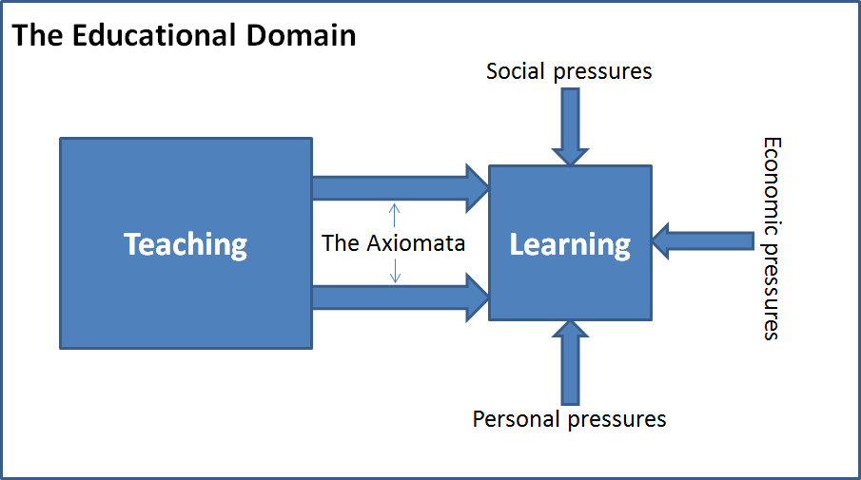

Teaching can happen without learning taking place. For example, bicycles exist even though the individual may not have tried to acquire the skill of riding one. Also, a teacher may hold forth without any of the pupils gaining knowledge (or even information). In database terms, this is a weak relationship. Teaching therefore becomes a service to learning, rather that the cause of learning (as it is viewed now). The diagram above describes Service Teaching.

A teaching element such as a teacher explaining something in a classroom or a hand-out being produced will only produce learning if one or more of the axiomata are being observed. If there is not a connection between the teaching element and the learner then the exercise is educationally pointless (although for a few teachers the point is merely to get a cheque at the end of each month). For example, an appalling teacher who goes into a classroom spouts their stuff under the mayhem in the classroom and then walks out has not taught because no learning elements have been achieved.

The same is true from the perspective of the learner. Imagine a shepherd on a hillside tending the flock who would love to have the better life that education can bring. That shepherd lacks access to the axiomata even though the teaching elements are out there and so no learning is happening.

This would make Service Teaching the theory filler in the middle of the Matrix of Education and supplements the practical work of John Hattie   
  
  
  
  
  
  
  
  
  
  
  
  
  
  
  
  
  
  
  
  
  
  
  
  
  
  
  
  
  
  
  
  
  
  
  
  
  
  
  
  
  
  
  
  
  
  
  
  
  
  
  
  
  
  
  
  
  
  
  
  
  
  
  
  
  
  
  
  
  
  
  
  
  
  
  
  
  
  
  
  
  
  
  
  
  
(Hattie 2009; Hattie 2012; Hattie & Yates 2013) and George Siemens   
  
  
  
  
  
  
  
  
  
  
  
  
  
  
  
  
  
  
  
  
  
  
  
  
  
  
  
  
  
  
  
  
  
  
  
  
  
  
  
  
  
  
  
  
  
  
  
  
  
  
  
  
  
  
  
  
  
  
  
  
  
  
  
  
(Siemens et al. 2011).

The quantity of education received can be measured by the number of atoms/IOKS of learning acquired. Since an atom/IOKS of learning would be one opinion, piece of information, item of understanding or new skill acquired an alternative term could be an oiks.

# How this could be applied

At the moment there are a convenient nine axiomata. Each is represented by a square in the diagram below. The green is the domain of good education (DGE).

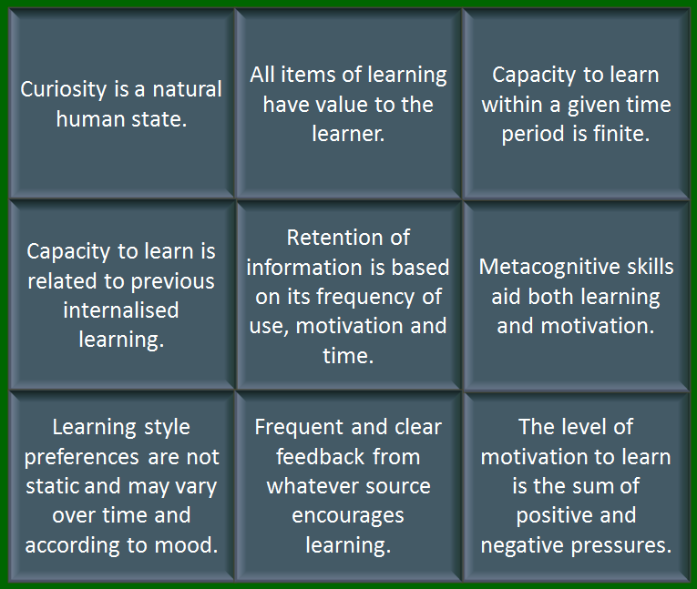

Imagine a list of teaching elements; verbal explanation, hand-outs, videos, discussions, etc. Each of these will cover different axiomata and may cover them to different depths.

The format of the teaching element will also determine whether a particular axiom has been covered. For example, a teacher in a classroom may cover none of the axiomata (as in the example above) or most of them, as happens in the majority of the classes nowadays.

Compound teaching elements would have the value of the sum of their individual components. For example, Moodle is only as good as the materials uploaded onto it. Moodle is not an activity in itself, but merely a repository of teaching elements. If Moodle (or any other composite activity) were to be “good education” then the sum of these activities would have to be the whole of the domain of good education (DGE).

However, let us make the optimistic assumption that each activity is the best it can be. We could then see which groups of activities are needed to cover the DGE. In theory then, we would have a method to assess whether students are getting the full deal (whether they are motivated to make use of it is another matter).

One could imagine a wide variety of compound activities, each of which covers the DGE. Using this range would provide variety and therefore help to keep the student engaged.

Suppose we had a mix of activities that included teaching (for example, with hand-outs, PowerPoint slides, etc.) that covered the DGE and another that included a VLE and complimented each other. The student could then move between them as they felt the need. At the moment, we call this blended learning.

# What happens when the DGE is not covered?

The emphasis at the moment is on good teaching. Therefore those at the chalk face are expected to keep up-to-date with the latest theories on good practice. Each new theory seeks to reach a niche not covered by others. The quantity of niches means that teachers are expected to juggle a vast array of tools and techniques.

The difference between what could have been learned by and individual and what actually was is the leakage in the educational system. The objective is to minimise the leakage within a system.

The discussion so far has been about the individual – the micro approach. The problem now becomes how these different individual needs can be met when in a group situation. What works for one will not necessarily work for another. What works for one today will not necessarily work for the same individual tomorrow.

The task is therefore to create a situation where there is enough redundancy built into a blended learning system to cater for all these needs simultaneously – the mid approach (the macro approach would consider optimising the educational environment for all in a society).

If an equation becomes large and complicated in mathematics then the chance are the problem is ill-defined. The same seems to be happening now in education.

Everyone, but especially teachers, would like every child to reach their potential, but reality gets in the way. The pressures limit to total education which is achievable. The economic pressures mean individual tuition for each child is not practical. Social pressures restrict the motivation and time available for learning. Personal pressures such as the need for company, sleep, etc. all curtail learning.

The next best solution is to see what can optimise learning within these boundaries. It becomes a form of linear programming. The axiomata become the limiting factors and society accepts a quantity of leakage. This is that portion of the DGE that is not covered.

# Testing the hypothesis

Testing this would have to be completed in stages:-

1. the axiomata have to be developed from both the general literature and the works of John Hattie.
2. to create a list of teaching elements, for example, teaching, using presentation graphics or allowing learners to experiment with paint and brushes.
3. the teaching elements would need to be matched to the axiomata to see which they could handle.
4. assess courses on our Moodle for how they meet the axiomata.
5. create an assessment of how a VTE might best operate by selecting appropriate teaching elements to maximise the use of the axiomata.
6. build that VTE and comparing its effectiveness against the results against.

This then forces the question of how to describe the list of axiomata. The items in the list of axiomata should:-

* tessellate completely.
* cover the whole of the domain of good education completely.

Qualification a) implies that the axiomata should fit together in such a way that they do not overlap or leave any gaps between them

Qualification b) says that they should describe everything that is considered to be “good education”. In practice, b) is unlikely to happen since the boundaries of good education shift over time. However, this merely suggests that the axiomata should be dynamic too.

# Conclusion

## This briefing document seeks to demonstrate that there are viable alternatives to current teaching strategies. These alternatives can be used both within the current systems (the pedagogical systems) and those outside it (the andragogical and heutagogical systems). The axiomata would be mechanism which binds these forms of learning to the teaching materials.

References

Comenius, J.A., 1986. *Didáctica magna*, Ediciones AKAL. Available at: http://soda.ustadistancia.edu.co/enlinea/SandroMunevar_Recursos_didacticos/Comenio_-_Didactica_Magna_-_pp_20-40.pdf.

Fleming, N.D., 1995. I’m different; not dumb. Modes of presentation (VARK) in the tertiary classroom. In *Research and Development in Higher Education, Proceedings of the 1995 Annual Conference of the Higher Education and Research Development Society of Australasia (HERDSA), HERDSA*. pp. 308–313.

Gillard, D., 2011. Education in England: a brief history - Chapter 2 - 1800 to 1860. Available at: http://www.educationengland.org.uk/history/chapter02.html.

Hattie, J., 2009. Visible learning. Available at: http://samples.sainsburysebooks.co.uk/9781134024124_sample_526335.pdf.

Hattie, J., 2012. *Visible learning for teachers: Maximizing impact on learning*, Routledge. Available at: https://www.egfl.org.uk/sites/default/files/SUMMARY%20OF%20VISIBLE%20LEARNING.pdf.

Hattie, J. & Yates, G.C., 2013. *Visible learning and the science of how we learn*, Routledge.

Holt, J., 1966. How children fail. *Literacy Research and Instruction*, 6(1), pp.4–7. Available at: http://www.ramanujanramanujan.com/folder/HOW%20CHILDREN%20FAIL%20-%20JOHN%20HOLT.pdf.

Kolb, D.A. & Fry, R.E., 1974. *Toward an applied theory of experiential learning*, MIT Alfred P. Sloan School of Management.

Maslow, A.H., 1943. A theory of human motivation. *Psychological review*, 50(4), p.370. Available at: http://psychclassics.yorku.ca/Maslow/motivation.html.

Overholser, J.C., 1993. Elements of the Socratic method: I. Systematic questioning. *Psychotherapy: Theory, Research, Practice, Training*, 30(1), p.67.

Robinson, K., 2008. Changing Education Paradigms. *RSA*.

Rousseau, J.-J. & Bloom, A.D., 1979. *Emile, or, on education*, Basic Books New York. Available at: http://ww2.chandler.k12.az.us/cms/lib6/AZ01001175/Centricity/Domain/963/Rousseau%20Essay%20and%20Target%20Notes.pdf.

Siemens, G. et al., 2011. Open Learning Analytics: an integrated & modularized platform. *Proposal to design, implement and evaluate an open platform to integrate heterogeneous learning analytics techniques*.

Vygotsky, L., 1978. *Mind in society: The development of higher psychological processes* S. S. & E. S. V. John-Steiner M. Cole, ed., Harvard University Press. Available at: http://www.ulfblanke.de/downloads/activity_theory/vygotsky1978.pdf.

1. A. Wicks, with University of Greenwich, Old Royal Naval College, 30 Park Row, London SE10 9LS (e-mail: wa02@gre.ac.uk).